

**Independent University, Bangladesh**

**School Management Web Application**

Prepared by

**Md Shahduzzaman**

[2131297@iub.edu.bd](mailto:2131297@iub.edu.bd)

[mdshahduzzaman@gmail.com](mailto:mdshahduzzaman@gmail.com)

Department of Computer Science and Engineering,

Independent University of Bangladesh.

Supervised By

**Ridwanullah Yousuf**

[ridu.rdla@gmail.com](mailto:ridu.rdla@gmail.com)

Adjunct Faculty

Department of Computer Science,

Independent University of Bangladesh.

**Declaration**

We hereby affirm that this project has been undertaken under the supervision of **Ridwanullah Yousuf**, Adjunct Faculty in the Department of Computer Science at the Independent University of Bangladesh. We also certify that neither this thesis nor any portion of it has been submitted elsewhere for the award of any degree. All sources of knowledge utilized in this work have been duly acknowledged. The design and development are the result of our own efforts.

|  |  |
| --- | --- |
|  |  |
| Md Shahduzzaman  ID: 2131297  Department of Computer Science and Engineering,  Independent University of Bangladesh. | **Ridwanullah Yousuf**  [ridu.rdla@gmail.com](mailto:ridu.rdla@gmail.com)  Adjunct Faculty  Department of Computer Science,  Independent University of Bangladesh. |

**Acknowledgments**

This project represents the culmination of our efforts, which would not have been possible without the generous support and assistance of numerous individuals and organizations. We extend our heartfelt gratitude to all who contributed to its success.

We are deeply grateful to our Supervisor, **Ridwanullah Yousuf**, Adjunct Faculty in the Department of Computer Science at the Independent University of Bangladesh, for his invaluable guidance, unwavering support, and provision of essential information throughout this project. His mentorship played a pivotal role in its completion.

We would also like to express our sincere appreciation to our parents, as well as the members of IUB and TESL, for their encouragement and cooperation, which greatly facilitated our progress.

Our special thanks go to industry professionals for their generous time and attention, which provided valuable insights for the project.

Lastly, we extend our gratitude to the faculty members of the Computer Science Department, who were consistently supportive, addressing our challenges and offering their technical expertise to resolve them.

**Dedication**

This project is dedicated to Allah, my Creator, my ultimate source of strength, guidance, and understanding. His blessings have been my unwavering support and motivation throughout this journey. Alhamdulillah for granting me the capacity to complete this work.

**Abstract**

This project focuses on the development of a School Management Web Application designed to streamline administrative and classroom management processes while improving communication between teachers and students. The application functions as a centralized platform where teachers can manage key tasks, including recording attendance, posting classwork, and uploading marksheets with ease.

Students benefit from this system by gaining access to their daily lessons, assignments, attendance records, academic results, and tuition fee history. Additionally, the application offers a feature for submitting leave applications, enhancing the overall user experience. By integrating these functionalities, the platform aims to simplify school operations and foster an efficient and transparent learning environment.

**Table of Contents**

Introduction 11

Overview 11

Purpose 11

Objective 11

Features 12

Admin Dashboard 12

Moderator Dashboard 12

Teacher 13

Accountant 14

Student 14

Technologies Used 15

Initial Project Proposal 15

Overview 15

Key Features 15

Gathering Requirements 16

Requirements Report 17

Initial Requirements Review 17

Client Discussion (Simulated) 17

Elicitation Process 18

Requirements Report 18

Most challenged Section 19

Subject Naming 20

Diagram Scenario 21

Sequence Diagram Scenario 21

Login 21

Creating a New User 22

Creating New Class 23

Creating New Subject 24

Assigning Subject into Class 25

Viewing Class and Subject 26

Submitting Payment 27

Viewing Payment Report 28

Viewing Student Profile 29

Posting Classwork 30

Taking Attendance 31

Posting Results 32

Viewing Classwork 33

Viewing Attendance 34

Viewing Result 35

Student viewing Tuition fees history 36

Student Submitting Leave Application 37

Logout 38

Activity Diagram 39

Login 39

Creating User 40

Creating Class 41

Creating Subject 42

Assigning Subject into Class 43

View Class & Subject 44

Submit Payment 45

Payment Report 46

Attendance 47

My Profile 48

Logout 49

ERD 50

Data Flow Diagram 51

Login 51

Create User 52

Create Class 53

Create Subject 54

Assign Subject into Class 55

View Class & Subject 56

Submit Payment 57

Payment Report 58

My Profile 59

View Student Profile 60

Logout 61

Project Details 62

Admin Dashboard 62

Moderator Dashboard 62

Teacher 63

Accountant 64

Student: 64

Conclusion 65

**Table of Figure**

**Sequence Diagram Scenario**

Figure 1. 1 Login 21

Figure 1. 2 Creating a New User 22

Figure 1. 3 Creating New Class 23

Figure 1. 4 Creating New Subject 24

Figure 1. 5 Assigning Subject into Class 25

Figure 1. 6 Viewing Class and Subject 26

Figure 1. 7 Submitting Payment 27

Figure 1. 8 Viewing Payment Report 28

Figure 1. 9 Viewing Student Profile 29

Figure 1. 10 Posting Classwork 30

Figure 1. 11 Taking Attendance 31

Figure 1. 12 Posting Results 32

Figure 1. 13 Viewing Classwork 33

Figure 1. 14 Viewing Attendance 34

Figure 1. 15 Viewing Result 35

Figure 1. 16 Student viewing Tuition fees history 36

Figure 1. 17 Student Submitting Leave Application 37

Figure 1. 18 Logout 38

**Activity Diagram**

Figure 2. 1 Login 39

Figure 2. 2 Creating User 40

Figure 2. 3 Creating Class 41

Figure 2. 4 Creating Subject 42

Figure 2. 5 Assigning Subject into Class 43

Figure 2. 6 View Class & Subject 44

Figure 2. 7 Submit Payment 45

Figure 2. 8 Payment Report 46

Figure 2. 9 Attendance 47

Figure 2. 10 My Profile 48

Figure 2. 11 Logout 49

**ERD**

Figure 3 ERD ………………………………………………………………………………………………………………………………………….50

**Data Flow Diagram**

Figure 4. 1 Login 51

Figure 4. 2 Create User 52

Figure 4. 3 Create Class 53

Figure 4. 4 Create Subject 54

Figure 4. 5 Assign Subject into Class 55

Figure 4. 6 View Class & Subject 56

Figure 4. 7 Submit Payment 57

Figure 4. 8 Payment Report 58

Figure 4. 9 My Profile 59

Figure 4. 10 View Student Profile 60

Figure 4. 11 Logout 61

# Introduction

## Overview

The idea is to develop a **School Management Web Application** that streamlines the management of school-related tasks and enhances communication between teachers and students. The web application will serve as a centralized platform where teachers can efficiently manage classroom activities, such as recording attendance, posting classwork, and uploading marksheets. Students will be able to access daily lessons, tasks, their results, attendance records, and tuition fee history, as well as submit leave applications through the portal.

## Purpose

The purpose of this project is to design and develop a comprehensive School Management Web Application that simplifies and enhances the administration and communication processes within educational institutions. By providing a centralized digital platform, the application aims to improve the efficiency of managing school-related tasks for teachers while fostering better engagement and access to information for students. Specifically, the project seeks to:

1. **Optimize Administrative Efficiency**: Streamline routine classroom management tasks such as attendance tracking, lesson planning, and marksheet preparation, reducing the workload for teachers and administrative staff.
2. **Enhance Communication and Collaboration**: Facilitate seamless communication between teachers and students, ensuring that essential information, such as classwork, daily lessons, and academic results, is readily available to students.
3. **Empower Students with Access to Information**: Provide students with a personalized portal where they can view their attendance records, academic progress, tuition fee history, and other school-related updates, promoting transparency and accountability.
4. **Support Digital Transition in Education**: Promote the adoption of modern digital tools in educational institutions, making processes more efficient, eco-friendly, and accessible to all stakeholders.
5. **Simplify Leave and Administrative Requests**: Offer an intuitive interface for students to submit leave applications and other administrative requests, eliminating paperwork and ensuring prompt responses.

## Objective

The main objective of this project is to digitalize the attendance, result data storing and student data storing system of a school. The student data storing system is more important because of the mis spelling of names in board registration.

## Features

In this project there are 5 types of users (Admin, Moderator, Accountant, Teacher and Student). Every type of user has its own dashboard. Every user need to login using their unique userID. The work of every dashboard is as follow:

### Admin Dashboard

* **Create user:** new user account will be created using the name, UserID, date of birth, father’s name, mother’s name, personal phone number, guardians phone number, present address, permanent address, user’s picture, birth certificate/NID’s pdf, father’s NID pdf, mother NID pdf and an initial password.
* **Attendance:** There will be a dropdown selection box by which the group will be selected (Example: Staff, class-1, class-2, etc.) then all the user’s information (Roll Number, User ID, Name, Last Day present or absent, today (check box)) of that group will appear into a table of 5 column. At the end there is a submit attendance button to submit today’s checked report. Checked report will be saved as “P” and unchecked will be “A”.
* **Report:** there will be 2 date pickers for setting the range and a apply button by which all the payment between the picked date will be shown along with the student user id, category and amount. At the end there will be a summary of that with the total payment history appeared and total amount.
* **Tuition fees:** there will be a input box to enter the user id, a dropdown selection box to select the bill category, a search button will find the id from the database then if that bill is paid there will be a paid message and if not paid then there will be 3 input box for Amount, Payment Status and Payment Date(automatically pick the current date and can be change), then a submit button. By submitting it the data will be stored in the database.
* **Logout**.

### Moderator Dashboard

* **Attendance:** There will be a dropdown selection box by which the group will be selected (Example: Staff, class-1, class-2, etc.) then all the user’s information (Roll Number, User ID, Name, Last Day present or absent, today (check box)) of that group will appear into a table of 5 column. At the end there is a submit attendance button to submit today’s checked report. Checked report will be saved as “P” and unchecked will be “A”.
* **Create user:** new user account (only teacher and student) will be created using the name, UserID, date of birth, father’s name, mother’s name, personal phone number, guardians phone number, present address, permanent address, user’s picture, birth certificate/NID’s pdf, father’s NID pdf, mother NID pdf and an initial password.
* **View Profile:** there is an input box to enter the user id and an apply button to load the information. Moderator can view all user profile except admin. Profile picture, name, roll number and a dropdown selection box to select the result of 1st term, 2nd term or Annul exam is to show. Then the full result of that term will be visible. Result contain Subject, Full Marks, Written, MCQ, Practical, Total, Highest, Letter Grade, Grade Point, Total of Monthly Exam, 20% of Monthly Exam, GPA without Additional Subject, GPA with Additional Subject, Comment, Total Marks, Procured Marks.
* **My profile:** Profile Picture, Name, User ID, Date of Birth, Father's Name, Mother's Name, Guardian's Contact, Present Address, Permanent Address. Then there will be 3 input boxes for changing Password, they are: Current password, New Password, Re-enter New Password. Then a submit button. By submitting the new password will be replaced with the old password in the database and a message will be shown that “Password change successfully”.
* **Logout.**

### Teacher

* **Attendance:** There will be a dropdown selection box by which the group will be selected (Example: Class-1, class-2, etc.) except staff. Then all the user’s information (Roll Number, User ID, Name, Last Day present or absent, today (check box)) of that group will appear in a table of 5 columns. At the end there is a submit attendance button to submit today’s checked report. Checked report will be saved as “P” and unchecked will be “A”.
* **Classwork:** Here all the assigned subjects will appear and by clicking on them he can post lessons on that subject. There will be a text box and a post button to post.
* **Result:** an input box for entering student user id then search button. By this the user id, name and roll number will appear, after this the teacher needs to select the class and subject from the selection box(the items will appear based on the classes and subjects assigned to that teacher.) Then to enter the mark there will be for input box for Full Marks, Written, MCQ, Practical, Total, Highest, Letter Grade, Grade Point, Total of Monthly Exam of that subject. Then a submit button to save the data to the database.
* **My profile:** Profile Picture, Name, User ID, Date of Birth, Father's Name, Mother's Name, Guardian's Contact, Present Address, Permanent Address. Then there will be 3 input boxes for changing Password, they are: Current password, New Password, Re-enter New Password. Then a submit button. By submitting the new password will be replaced with the old password in the database and a message will be shown that “Password change successfully”.
* **Student Profile:** there is an input box to enter the user id and an apply button to load the information. Profile picture, name, roll number and a dropdown selection box to select the result of 1st term, 2nd term or Annul exam is to show. Then the full result of that term will be visible. Result contain Subject, Full Marks, Written, MCQ, Practical, Total, Highest, Letter Grade, Grade Point, Total of Monthly Exam, 20% of Monthly Exam, GPA without Additional Subject, GPA with Additional Subject, Comment, Total Marks, Procured Marks.
* **Logout.**

### Accountant

* **Tuition fees:** there will be a input box to enter the user id, a dropdown selection box to select the bill category, a search button will find the id from the database then if that bill is paid there will be a paid message and if not paid then there will be 3 input box for Amount, Payment Status and Payment Date(automatically pick the current date and can be change), then a submit button. By submitting it the data will be stored in the database.
* **My profile:** Profile Picture, Name, User ID, Date of Birth, Father's Name, Mother's Name, Guardian's Contact, Present Address, Permanent Address. Then there will be 3 input boxes for changing Password, they are: Current password, New Password, Re-enter New Password. Then a submit button. By submitting the new password will be replaced with the old password in the database and a message will be shown that “Password change successfully”.
* **Logout.**

### Student

* **Classwork:** The assigned class will be connected to the dashboard and assigned subjects to that class will appear here in the table with columns of Subject and Lesson. Before the table there will be a date picker (loaded with current date) so that the students can check the previous day’s lesson.
* **Attendance:** A dropdown selection box to select the month (current month will be preloaded). Then there will be a calendar like table where the present days will be green and absent will be red filled box. The weekly holydays will be ash colored.
* **Tuition fees:** A table with column consists of Category, Amount, Status (Paid/due), Payment Date (If paid) with the payment records.
* **My profile:** Profile Picture, Name, User ID, Date of Birth, Father's Name, Mother's Name, Guardian's Contact, Present Address, Permanent Address. Then there will be 3 input boxes for changing Password, they are: Current password, New Password, Re-enter New Password. Then a submit button. By submitting the new password will be replaced with the old password in the database and a message will be shown that “Password change successfully”.
* **Logout.**

## Technologies Used

* HTML
* CSS
* PHP
* SQL

# Initial Project Proposal

## Overview

The idea is to develop a **School Management Web Application** that streamlines the management of school-related tasks and enhances communication between teachers and students. The web application will serve as a centralized platform where teachers can efficiently manage classroom activities, such as recording attendance, posting classwork, and uploading marksheets. Students will be able to access daily lessons, tasks, their results, attendance records, and tuition fee history, as well as submit leave applications through the portal.

The web application will be designed to be user-friendly and responsive, ensuring smooth access from any device, including mobile phones, tablets, and desktops. It will aim to improve administrative efficiency, transparency in student performance tracking, and overall communication within the school environment.

## Key Features

1. **Attendance Management:**
   * Teachers will be able to take and record students' attendance.
   * Students can view their personal attendance records at any time.
2. **Classwork & Lesson Posting:**
   * Teachers will post daily lessons, homework, and classwork by class/subject.
   * Students can view and download assigned tasks and lessons.
3. **Marksheets & Results:**
   * Teachers will upload marksheets and results after exams.
   * Students can view their individual results and performance reports.
4. **Tuition Fees Management:**
   * Students can check their tuition fees payment history and track any pending dues.
5. **Leave Application Submission:**
   * Students will be able to submit leave applications digitally.
   * Teachers and school administrators can review and approve or reject leave requests.
6. **User-Friendly Dashboard:**
   * A role-based dashboard will be implemented: one for teachers (to manage classwork, attendance, and grades) and another for students (to access tasks, lessons, and personal records).
   * Teachers and students will have clear, separate workflows for their respective functions.
7. **Responsive Design:**
   * The web app will be fully responsive, ensuring seamless access on mobile devices, tablets, and desktops.
   * The interface will be intuitive and easy to navigate for both teachers and students, regardless of the device used.

# Gathering Requirements

The first step in developing the School Management Web Application is to gather comprehensive requirements from all stakeholders involved, including school administrators, teachers and students. This process involves identifying the specific needs and challenges faced by each group to ensure the platform addresses their expectations effectively. For administrators, the focus is on features like attendance management, marksheet generation, and tuition fee tracking. Teachers require tools for posting classwork, managing lesson plans, and monitoring student performance. Students need an intuitive interface to access their attendance records, academic results, and daily tasks, as well as submit leave applications. Parents may benefit from features that allow them to monitor their child’s academic progress and fee payment history. To collect this information, methods such as interviews, surveys, and workshops will be employed, ensuring the requirements are well-documented, prioritized, and aligned with the project's goals. This step is critical for designing a robust and user-centric solution that meets the unique demands of a modern educational environment.

## Requirements Report

**Project Title:** School Management System  
**Objective:** To create a safe and easy-to-use system that helps teachers, students, and administrators keep records of attendance, classwork and lesson posting, grade sheets and results, and tuition fees.

## Initial Requirements Review

|  |  |
| --- | --- |
| **Requirement** | **Description** |
| **Attendance Management** | * Teachers can take and record student attendance. * Students can view their personal attendance records at any time. |
| **Classwork & Lesson Posting** | * Teachers can post daily lessons, homework, and classwork by class or subject. * Students can view and download assigned tasks and lessons. |
| **Marksheets & Results** | * Teachers upload marksheets and results after exams. * Students can view their individual results and performance reports. |
| **Tuition Fees Management** | * Students can check their tuition fee payment history and track any pending dues. * Teachers and school administrators can review and approve or reject leave requests. |

## Client Discussion (Simulated)

During the discussion with the client, all 4 requirements were discussed, and they ask for some modifications to a existing feature and two new features was proposed.

## Elicitation Process

New and Modified Requirements:

|  |  |  |
| --- | --- | --- |
| **Requirement** | **New or modified** | **Details** |
| Late Attendance record | New | Late attendance option in any period can be taken and time will be saved. |
| Teacher’s ID logs in attendance sheet | New | The attendance record taker’s ID will be recorded with time. |
| Password Encryption | Modified | To use DES or AES algorithm to secure the passwords. |

## Requirements Report

|  |  |  |
| --- | --- | --- |
| **Requirement** | **Old, new or modified** | **Details** |
| **Attendance Management** | Old | * Teachers can take and record student attendance. * Students can view their personal attendance records at any time. |
| Late Attendance record | New | Late attendance option in any period can be taken and time will be saved. |
| Teacher’s ID logs in attendance sheet | New | The attendance record taker’s ID will be recorded with time. |
| Password Encryption | Modified | To use DES or AES algorithm to secure the passwords. |
| **Classwork & Lesson Posting** | Old | * Teachers can post daily lessons, homework, and classwork by class or subject. * Students can view and download assigned tasks and lessons. |
| **Marksheets & Results** | Old | * Teachers upload marksheets and results after exams. * Students can view their individual results and performance reports. |
| **Tuition Fees Management** | Old | * Students can check their tuition fee payment history and track any pending dues. * Teachers and school administrators can review and approve or reject leave requests. |

# Most challenged Section

Designing the marksheet was the most difficult part of this project as the traditional way of this process was as follows:

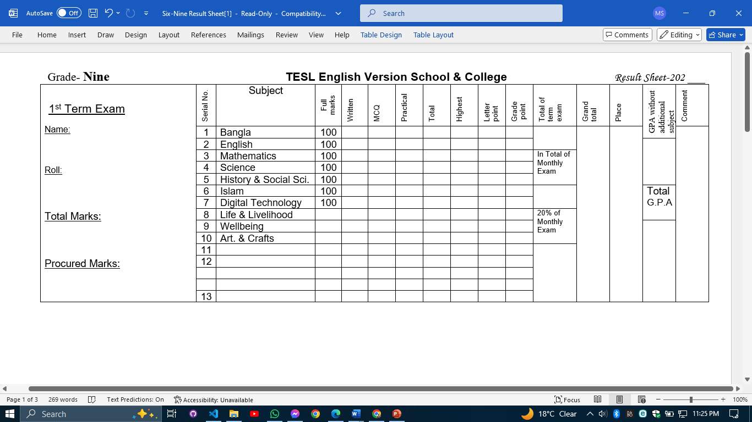

## Subject Naming

For this project we design a new way to store mark for this Institution that includes the subject mapping with subject code, they are:

|  |  |  |
| --- | --- | --- |
| **Subject Name** | **Code** | **SubjectID** |
| Bangla 1st Paper | 101 | BAN-101 |
| Bangla 2nd Paper | 102 | BAN-102 |
| English 1st Paper | 107 | ENG-107 |
| English 2nd Paper | 108 | ENG-108 |
| Math | 109 | MAT-109 |
| Physics | 136 | PHY-136 |
| Chemistry | 137 | CHE-137 |
| Biology | 138 | BIO-138 |
| Higher Math | 126 | MAT-126 |
| Information & Communication Technology | 154 | ICT-154 |
| Islam & Moral Education | 111 | IME-111 |
| Bangladesh & Global Studies | 150 | BGS-150 |
| Agriculture Studies | 134 | AGS-134 |

# Diagram Scenario

## Sequence Diagram Scenario

### Login

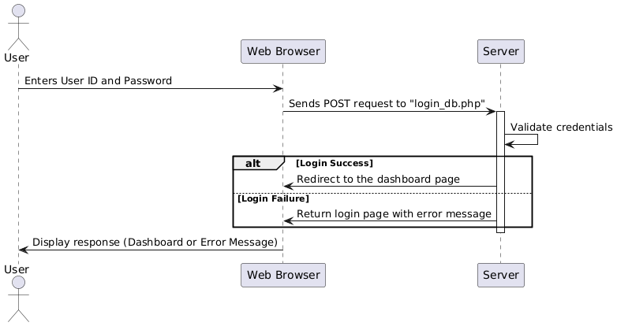

Figure 1. Login

### Creating a New User

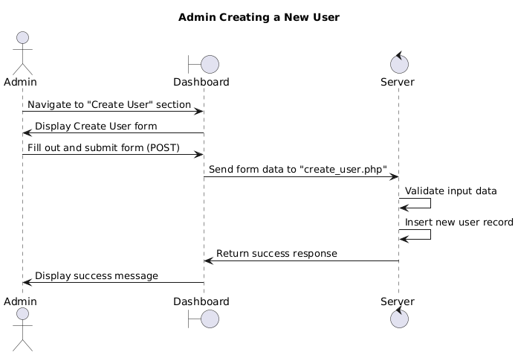

Figure 1. Creating a New User

### Creating New Class

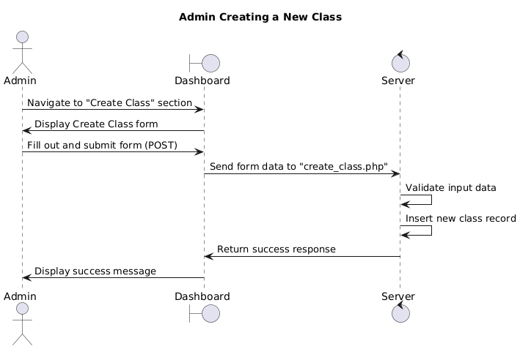

Figure 1. Creating New Class

### Creating New Subject

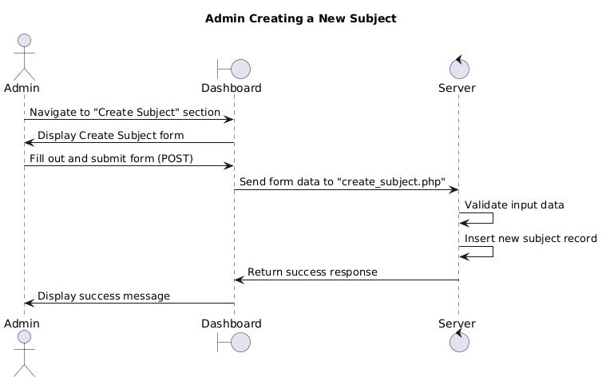

Figure 1. Creating New Subject

### Assigning Subject into Class

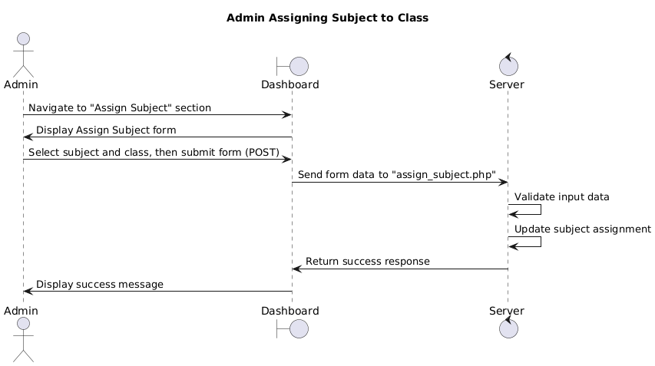

Figure 1. Assigning Subject into Class

### Viewing Class and Subject

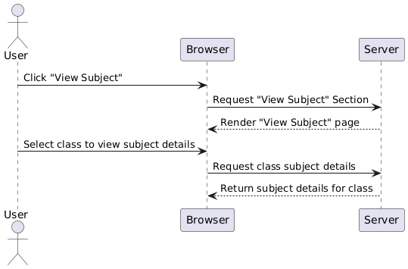

Figure 1. Viewing Class and Subject

### Submitting Payment

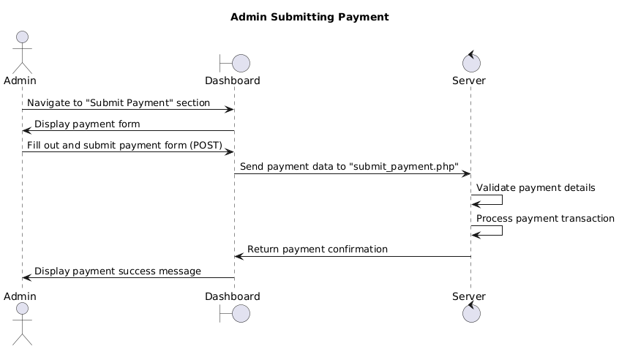

Figure 1. Submitting Payment

### Viewing Payment Report

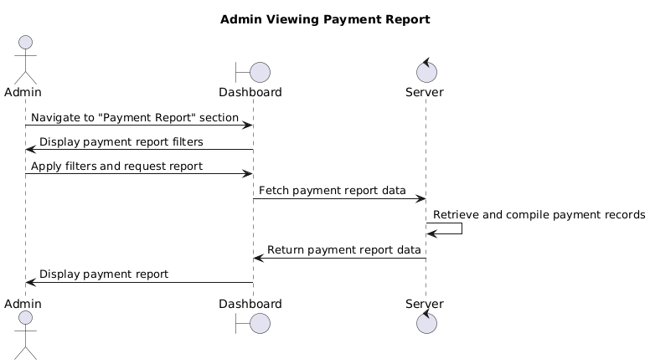

Figure 1. Viewing Payment Report

### Viewing Student Profile

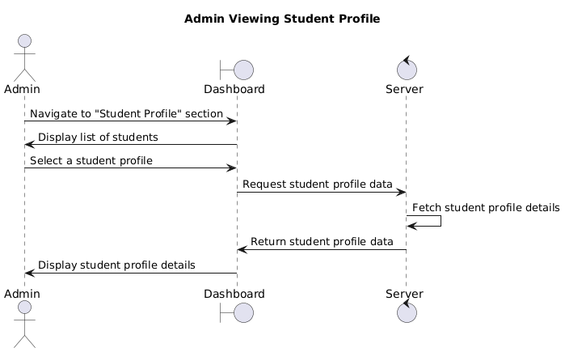

Figure 1. Viewing Student Profile

### Posting Classwork

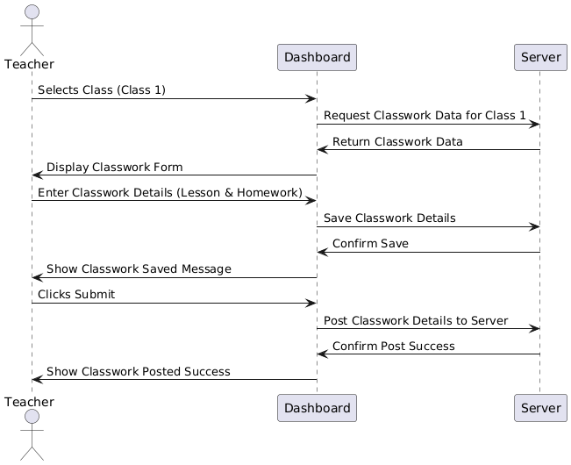

Figure 1. Posting Classwork

### Taking Attendance

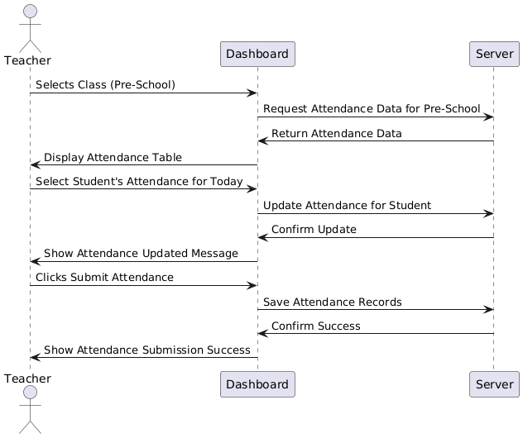

Figure 1. Taking Attendance

### Posting Results

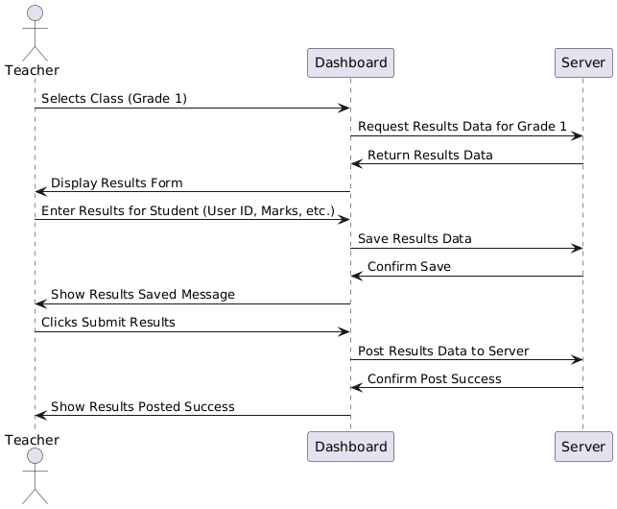

Figure 1. Posting Results

### Viewing Classwork

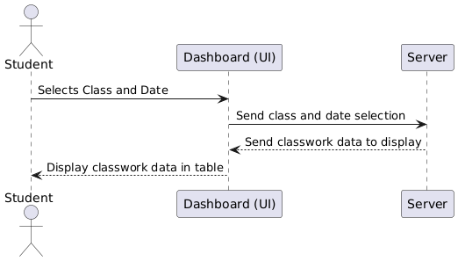

Figure 1. Viewing Classwork

### Viewing Attendance

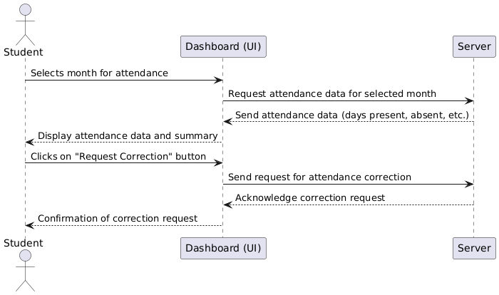

Figure 1. Viewing Attendance

### Viewing Result

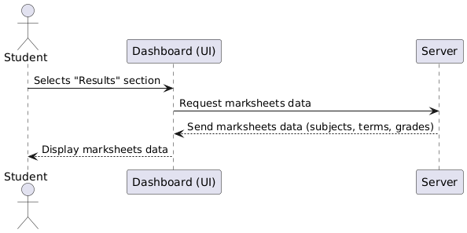

Figure 1. Viewing Result

### Student viewing Tuition fees history

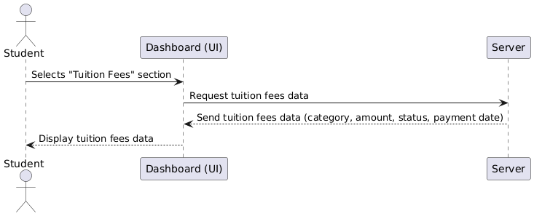

Figure 1. Student viewing Tuition fees history

### Student Submitting Leave Application

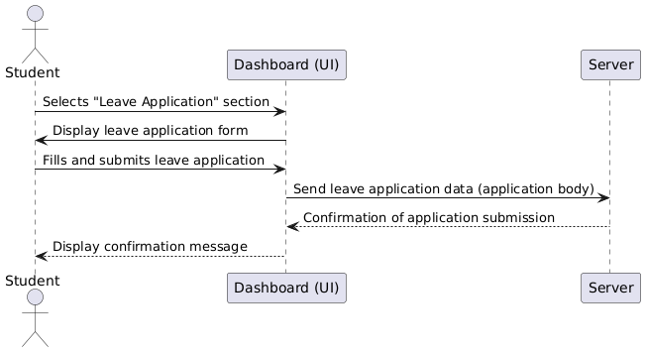

Figure 1. Student Submitting Leave Application

### Logout

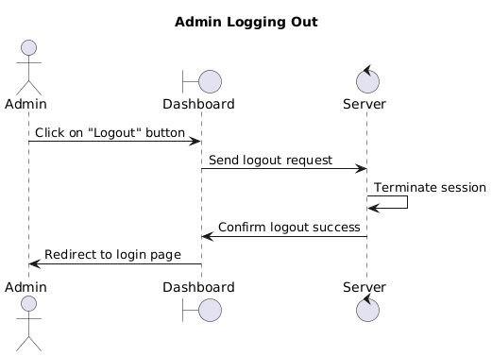

Figure 1. Logout

## Activity Diagram

Figure 2. Activity Diagram

### Login

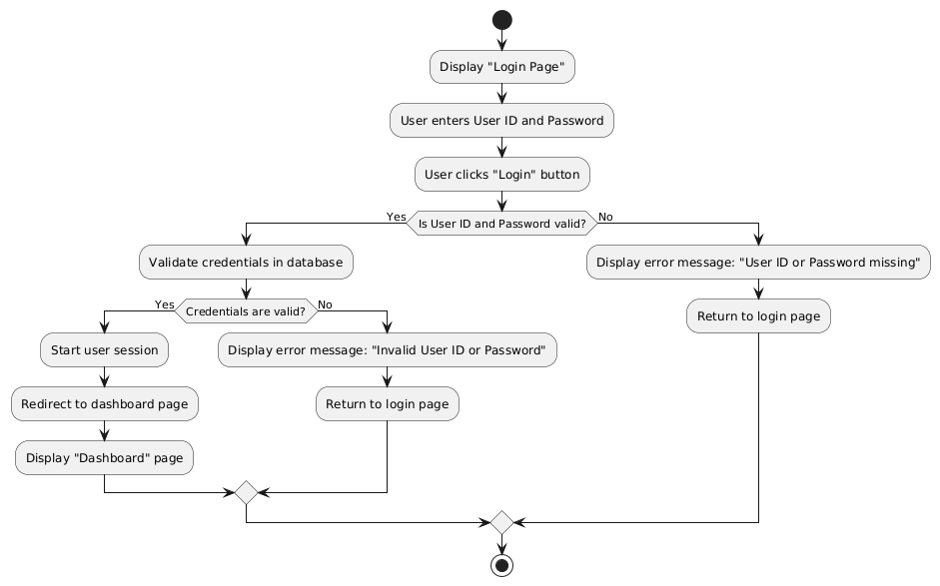

Figure 2. Login

### Creating User

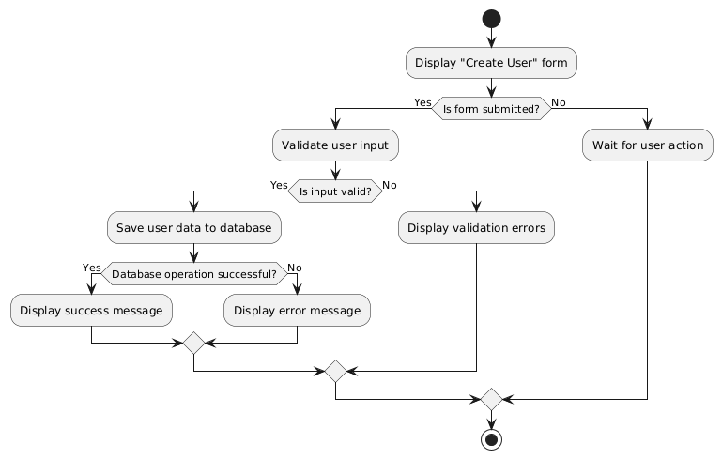

Figure 2. Creating User

### Creating Class

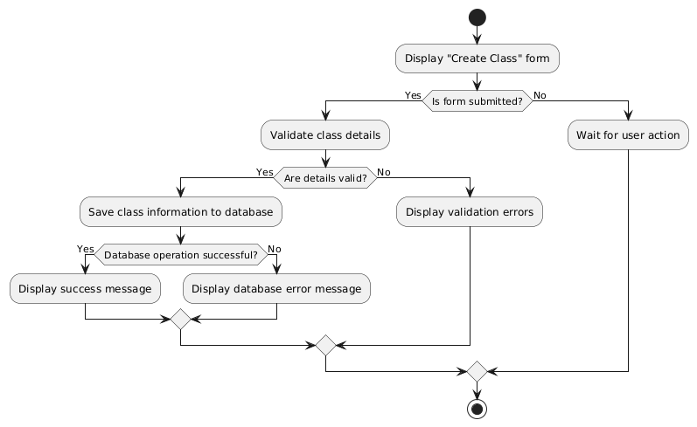

Figure 2. Creating Class

### Creating Subject

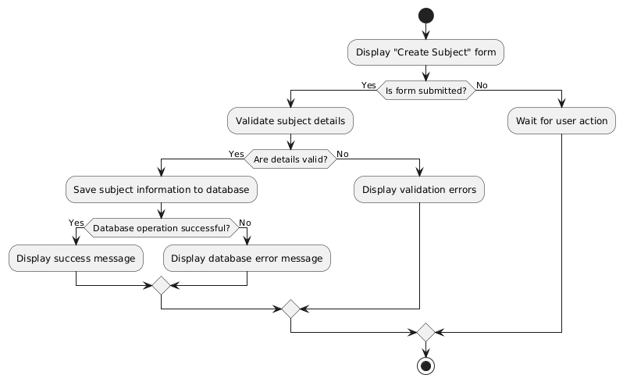

Figure 2. Creating Subject

### Assigning Subject into Class

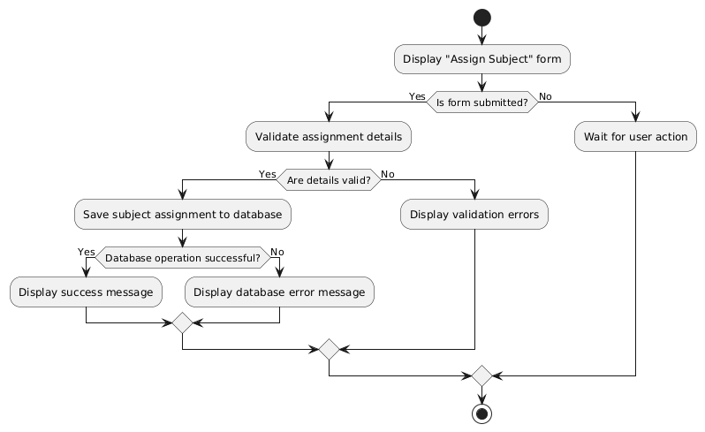

Figure 2. Assigning Subject into Class

### View Class & Subject

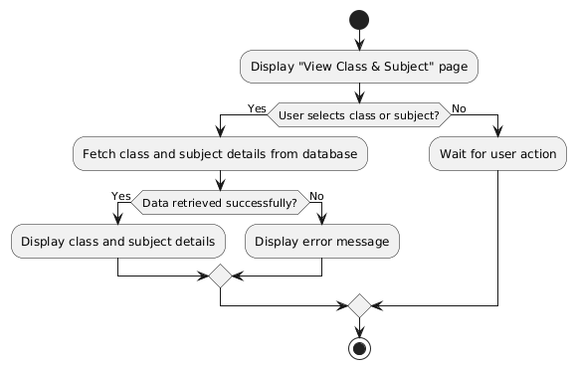

Figure 2. View Class & Subject

### Submit Payment

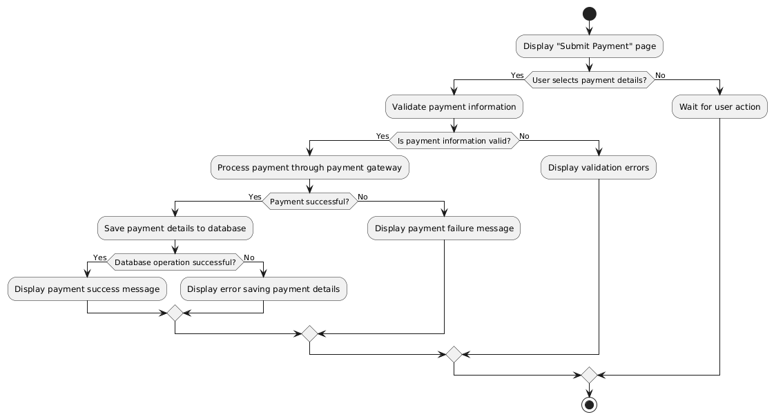

Figure 2. Submit Payment

### Payment Report

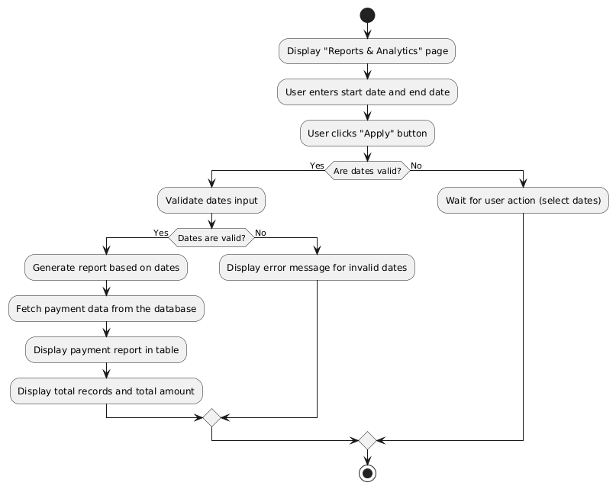

Figure 2. Payment Report

### Attendance

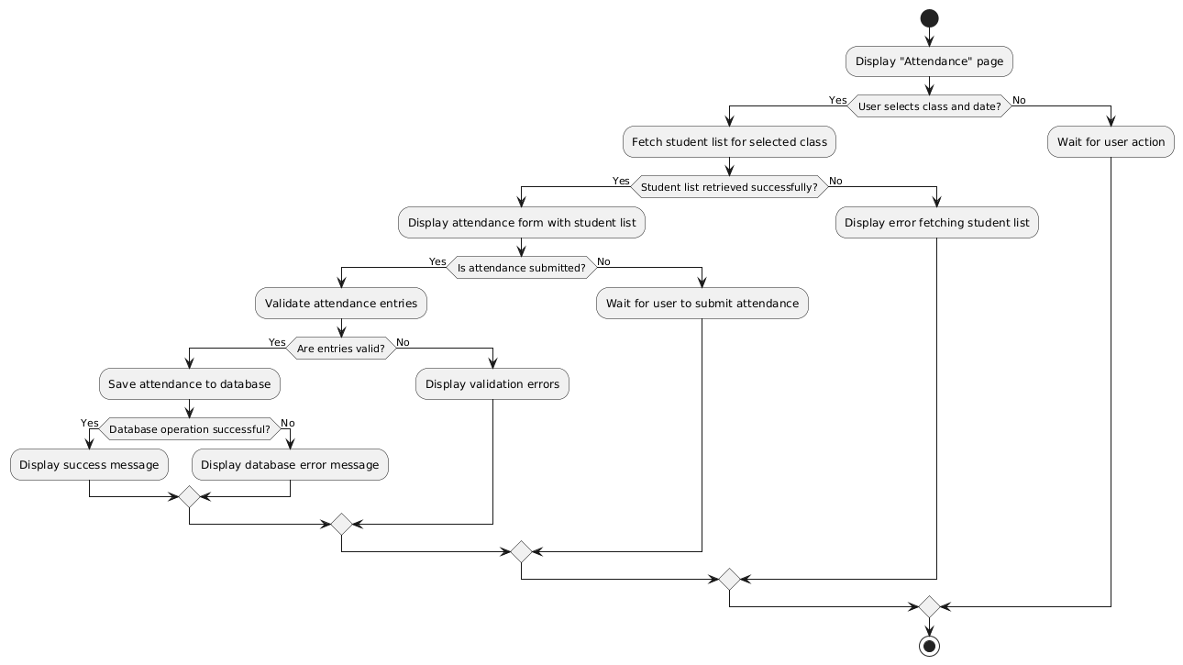

Figure 2. Attendance

### My Profile

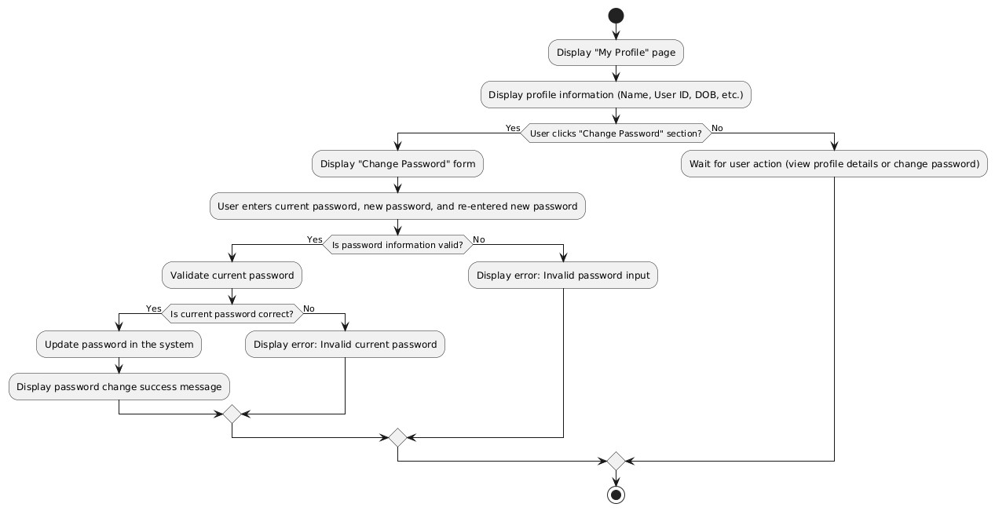

Figure 2. My Profile

### Logout

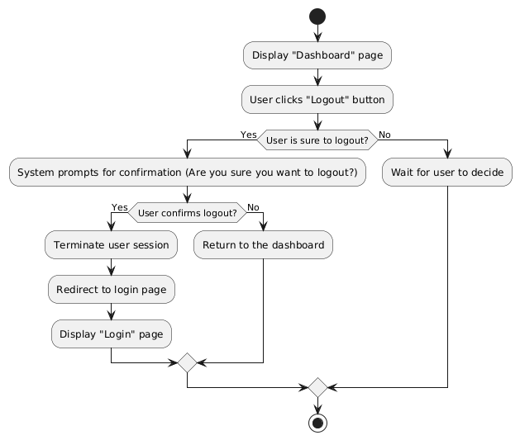

Figure 2. Logout

## ERD

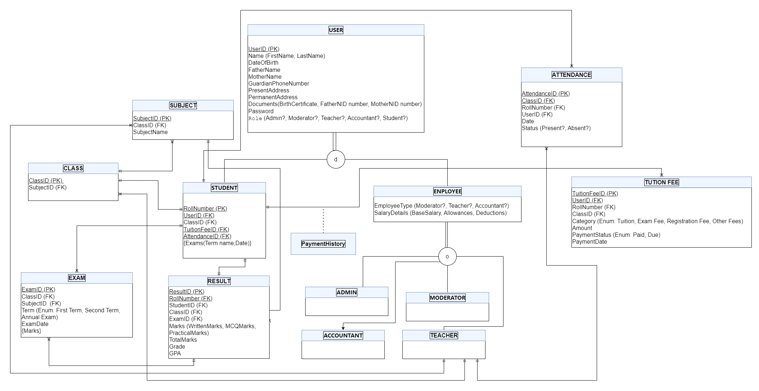

Figure 3 ERD

## Data Flow Diagram

Figure 4. Data Flow Diagram

### Login

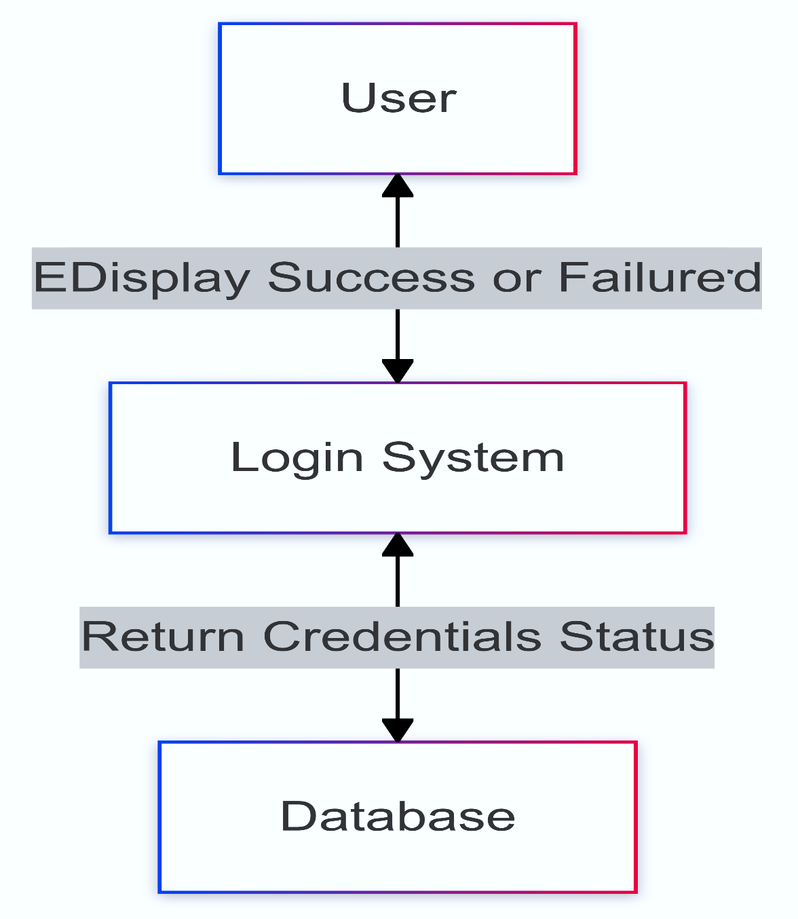

Figure 4. Login

### Create User

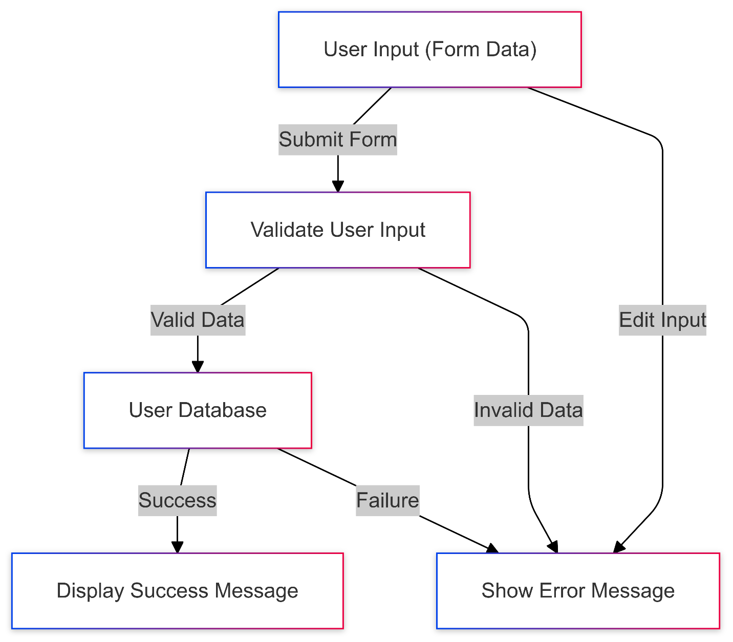

Figure 4. Create User

### Create Class

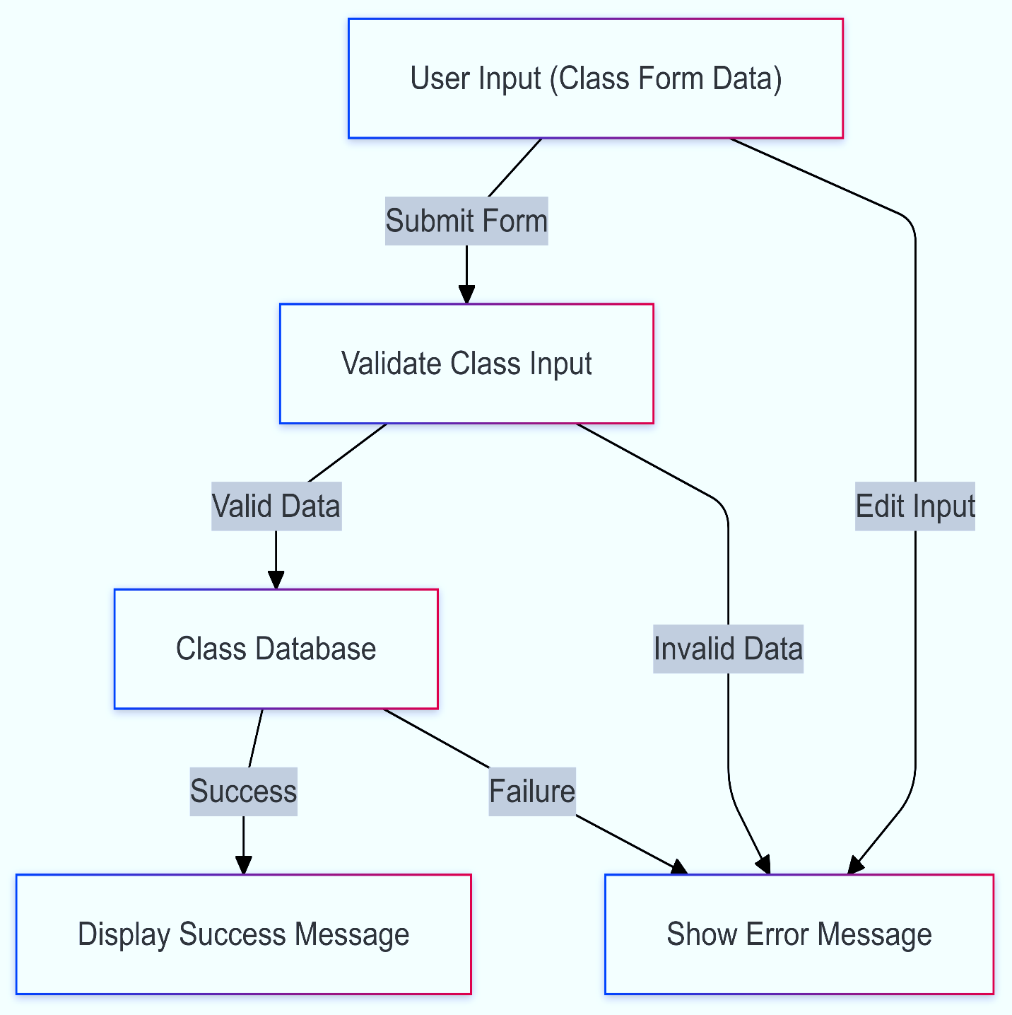

Figure 4. Create Class

### Create Subject

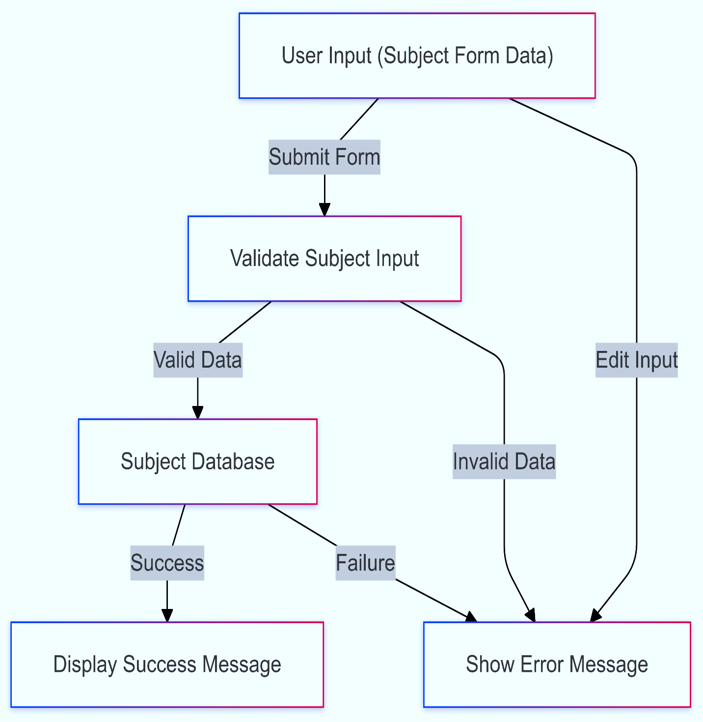

Figure 4. Create Subject

### Assign Subject into Class

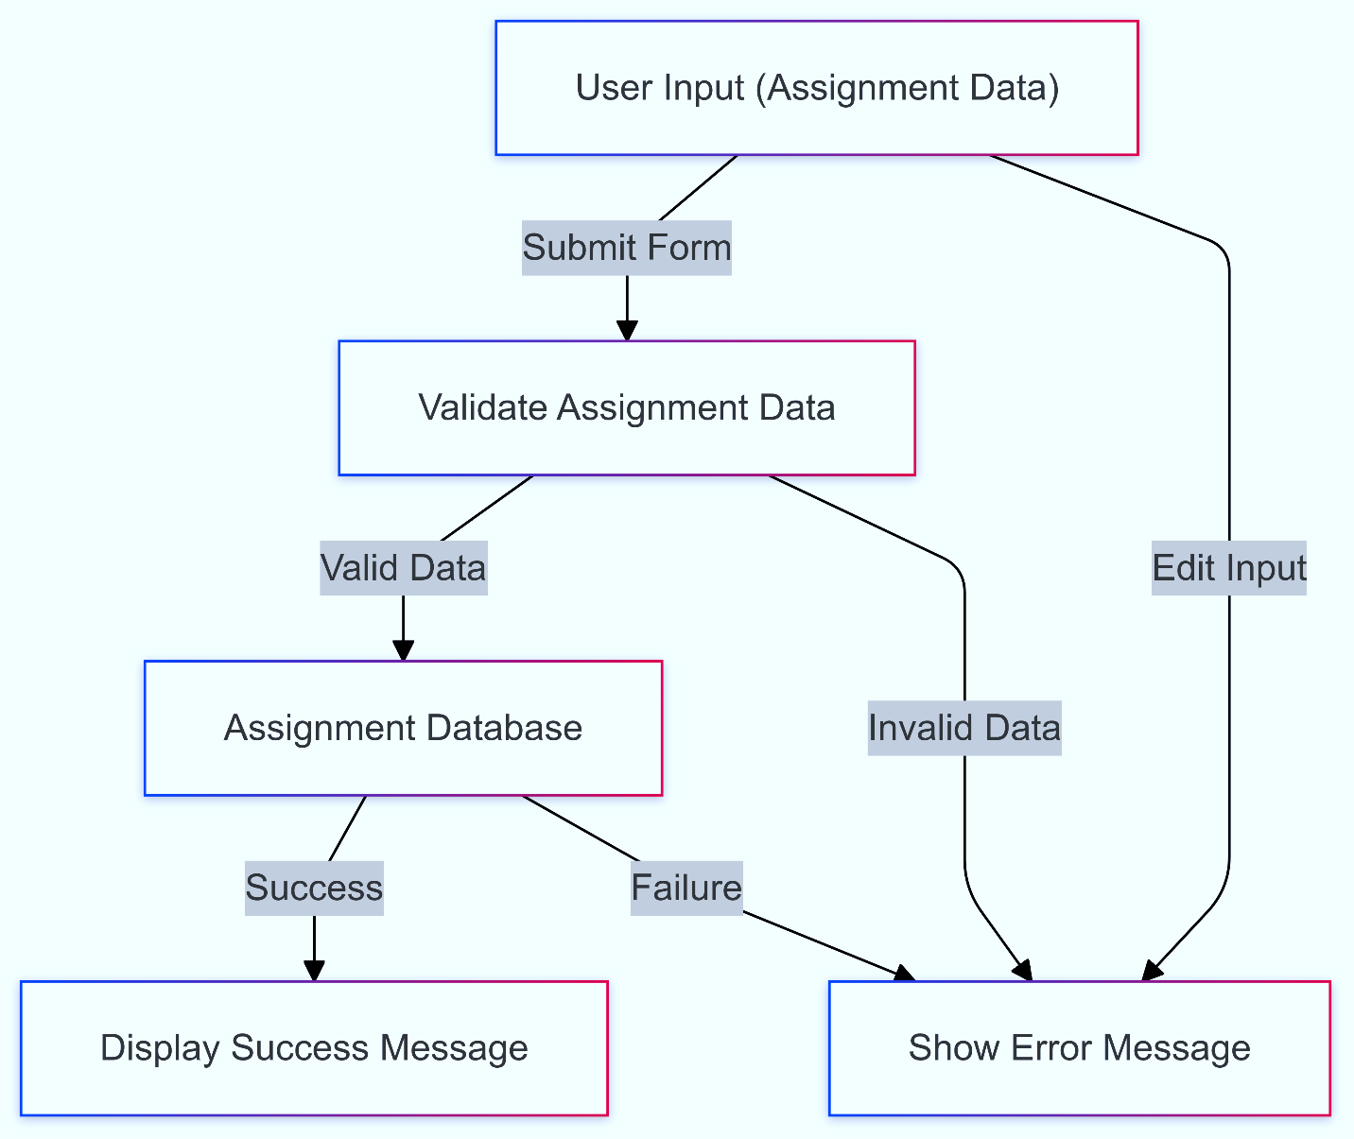

Figure 4. Assign Subject into Class

### View Class & Subject

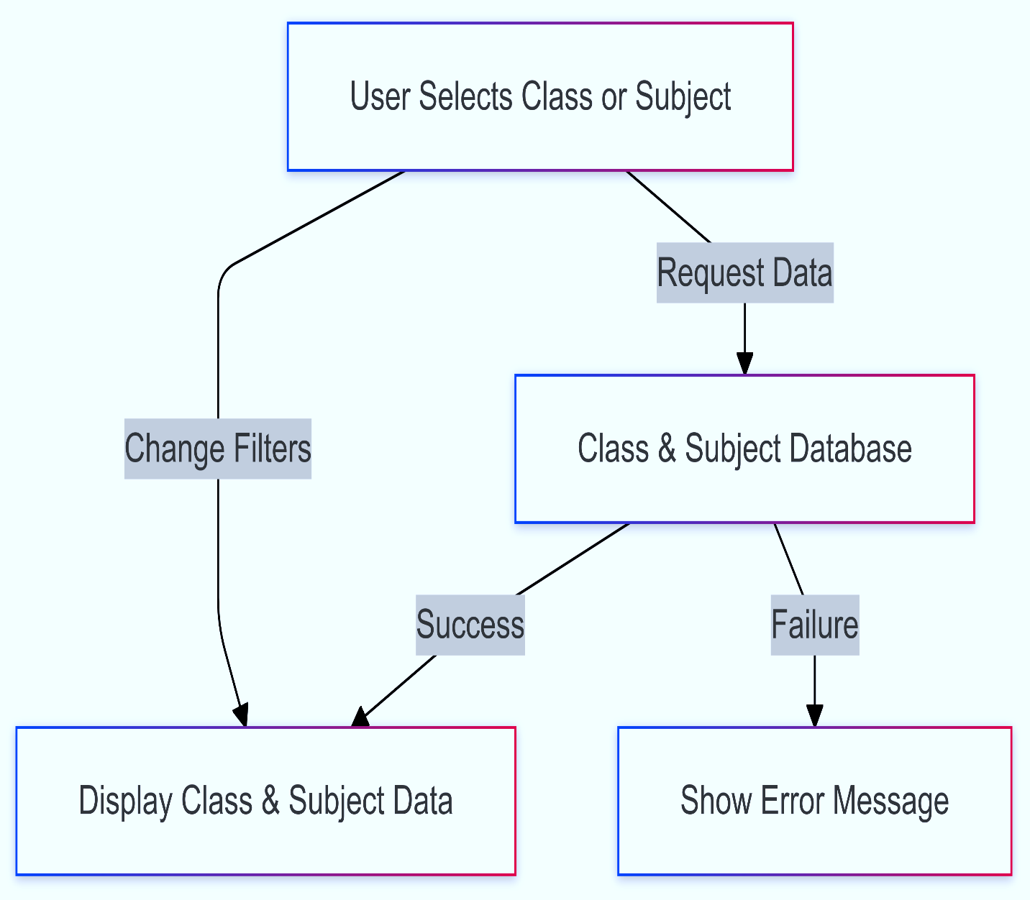

Figure 4. View Class & Subject

### Submit Payment

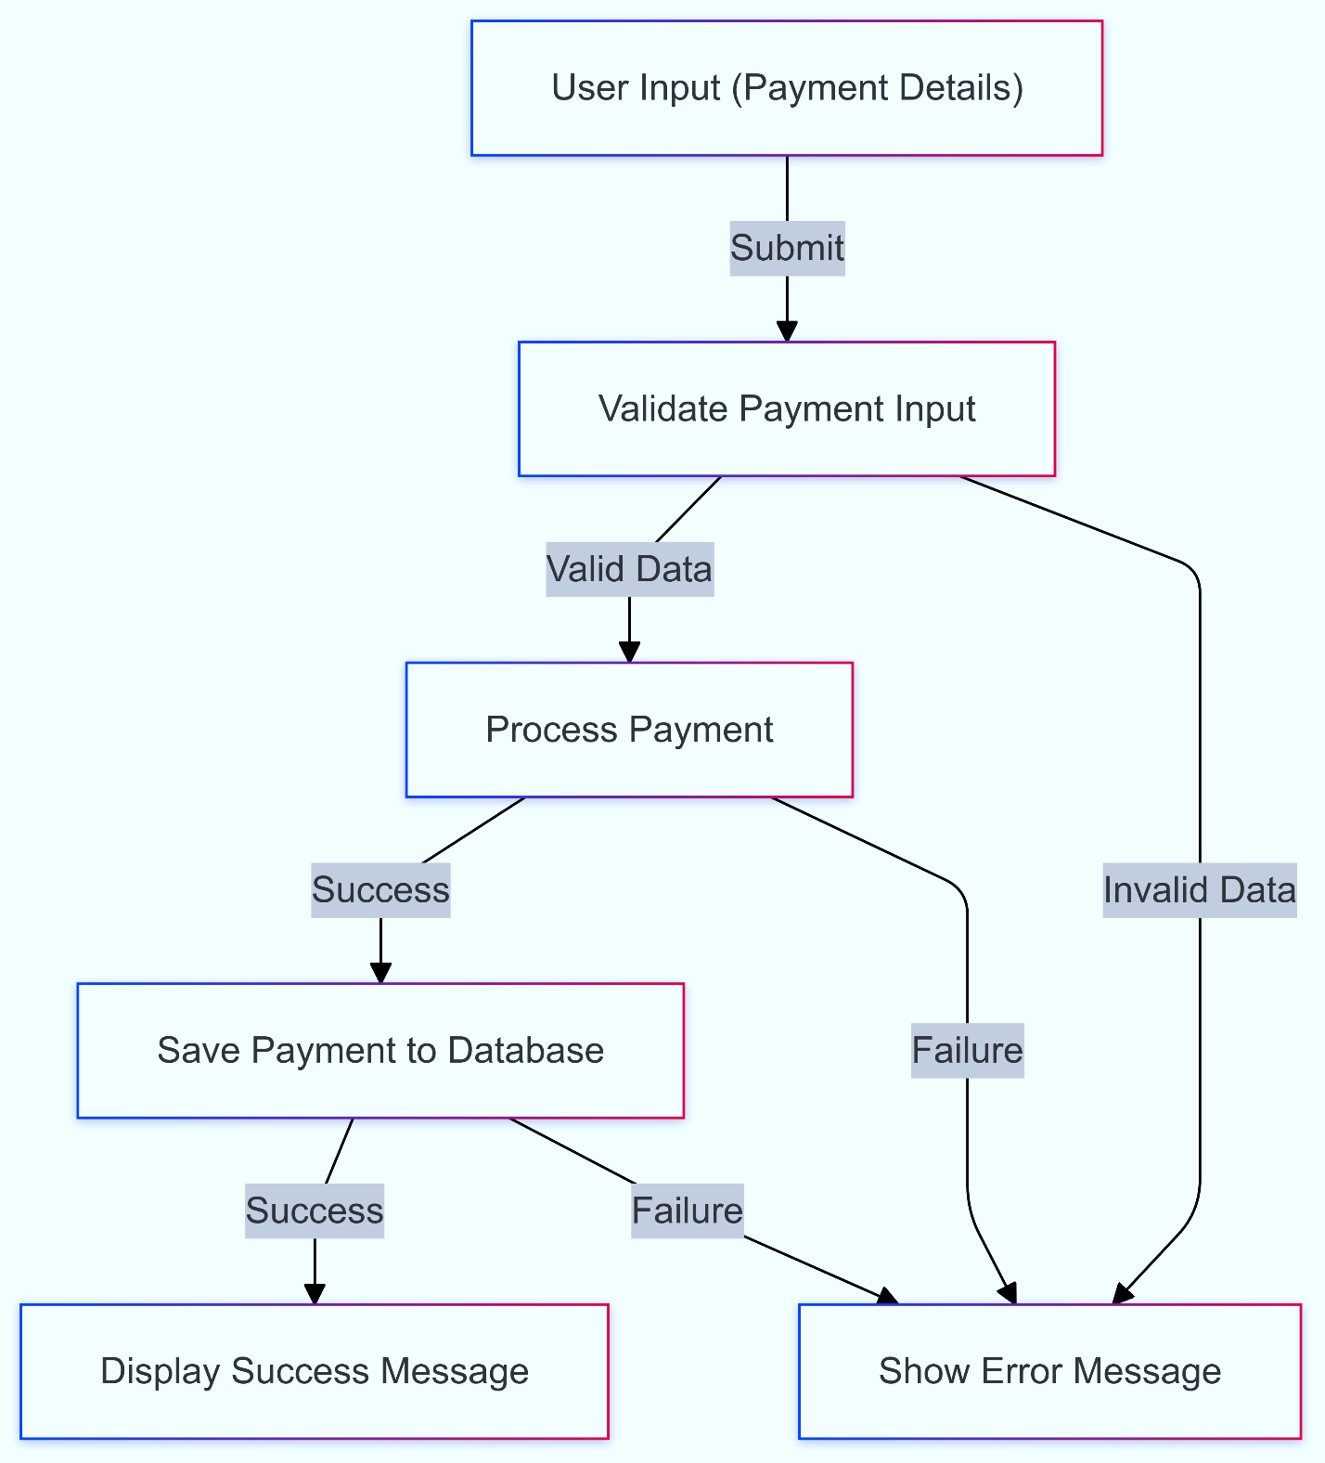

Figure 4. Submit Payment

### Payment Report

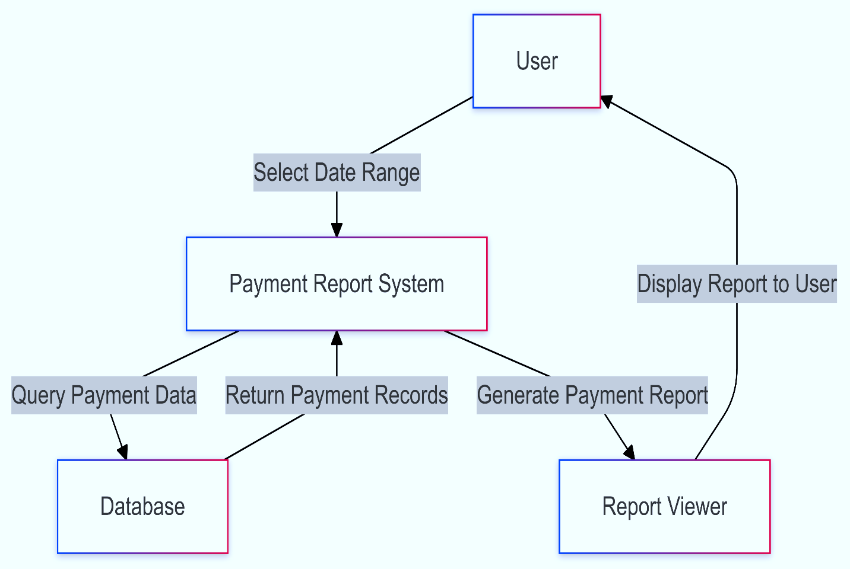

Figure 4. Payment Report

### My Profile

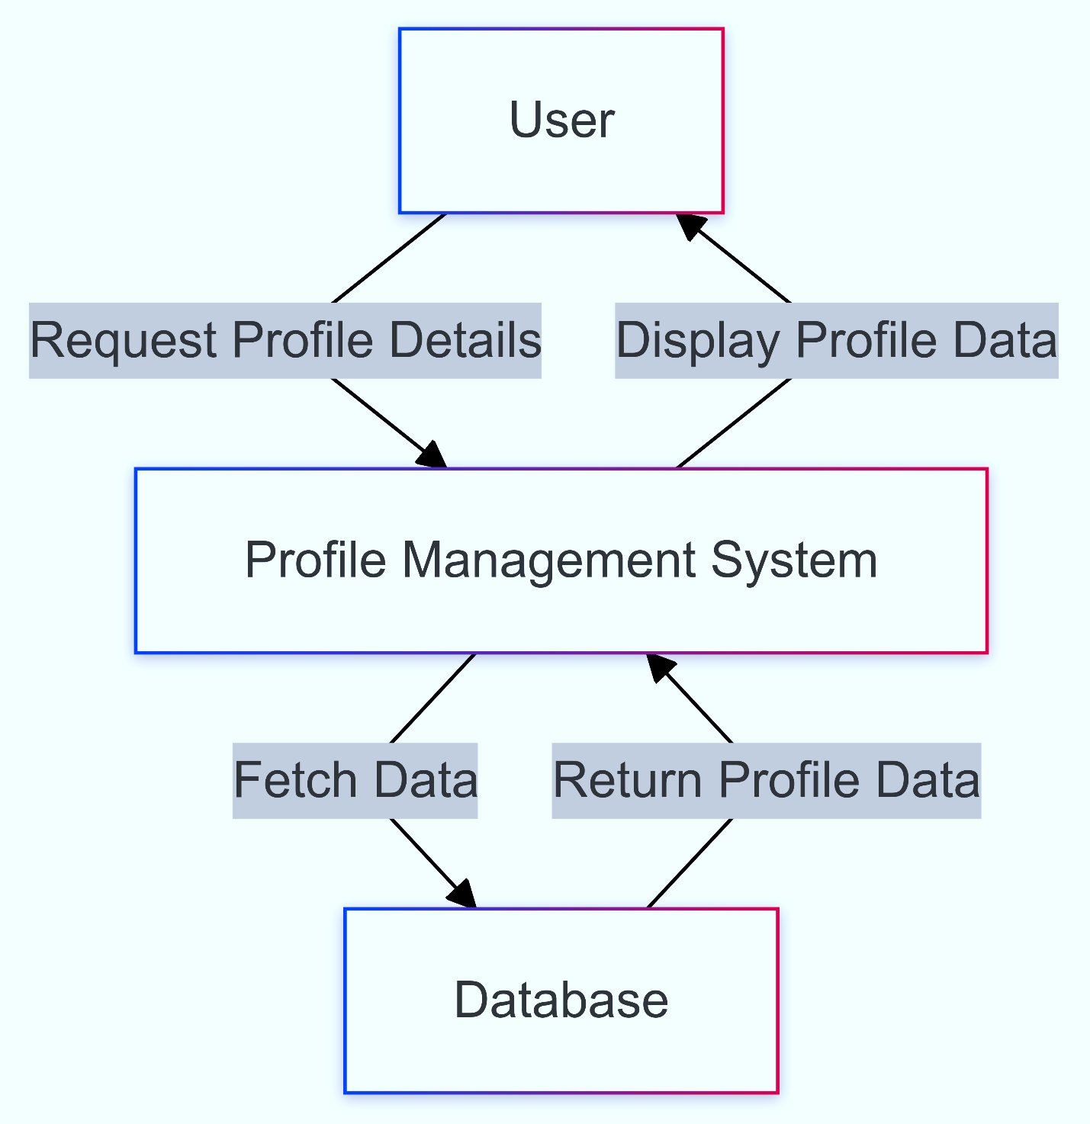

Figure 4. My Profile

### View Student Profile

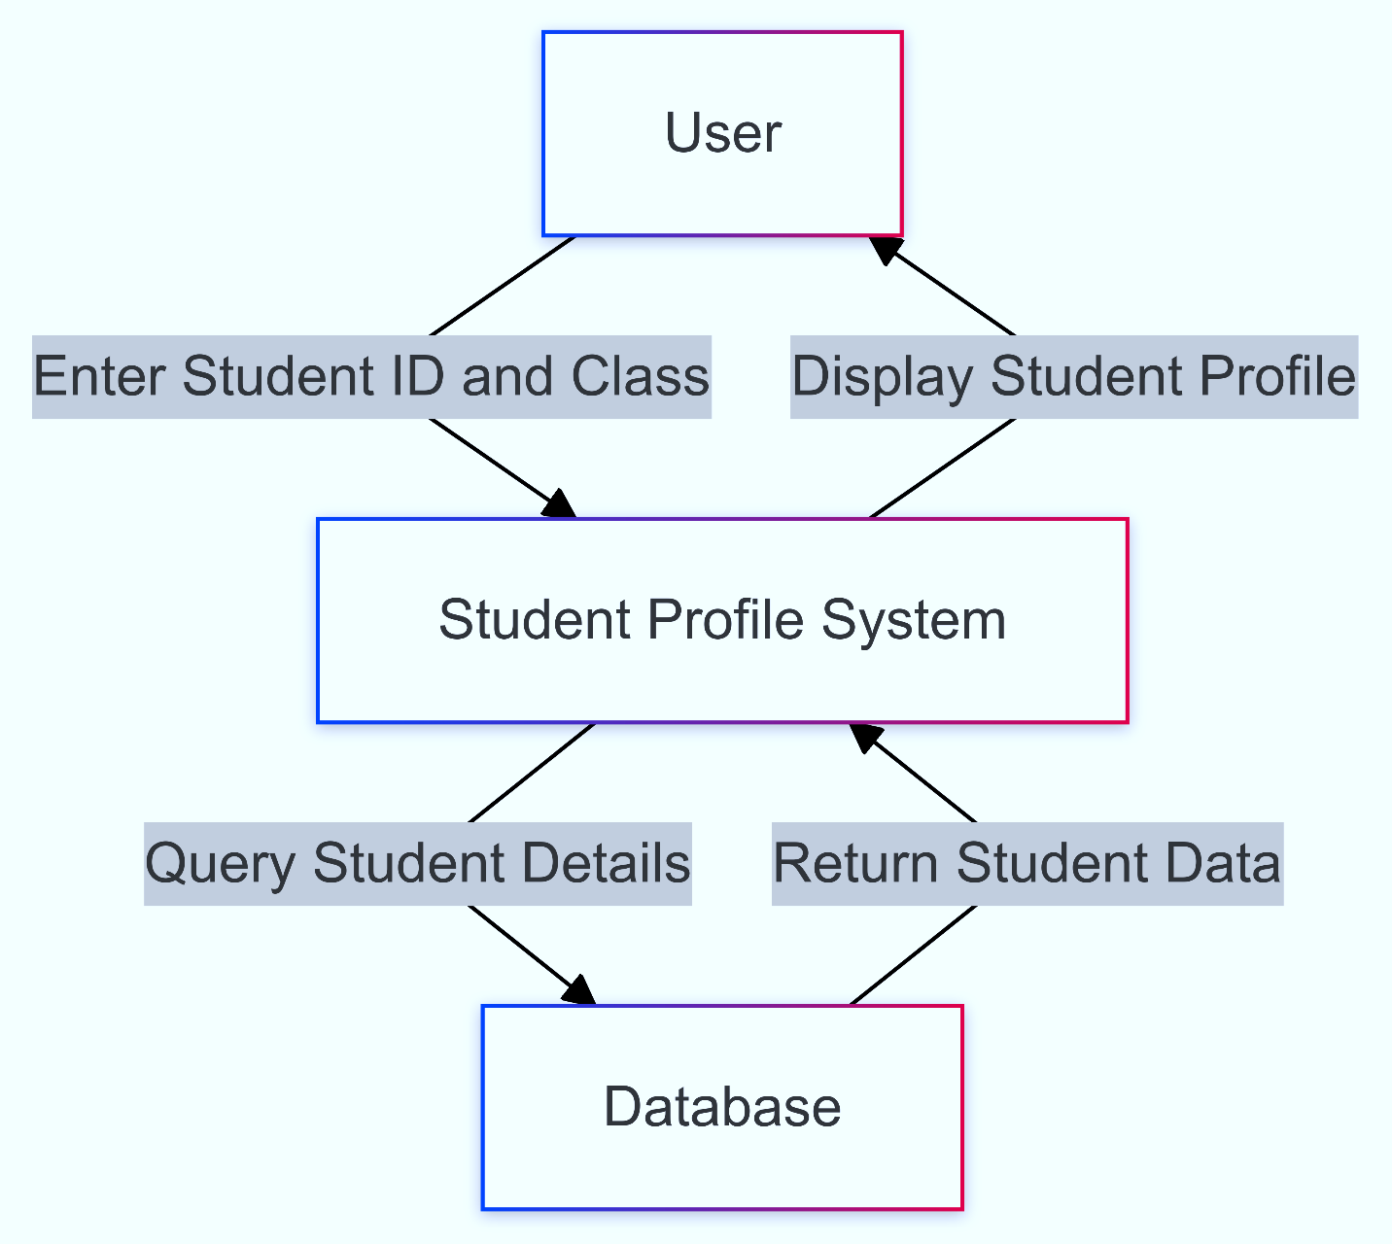

Figure 4. View Student Profile

### Logout

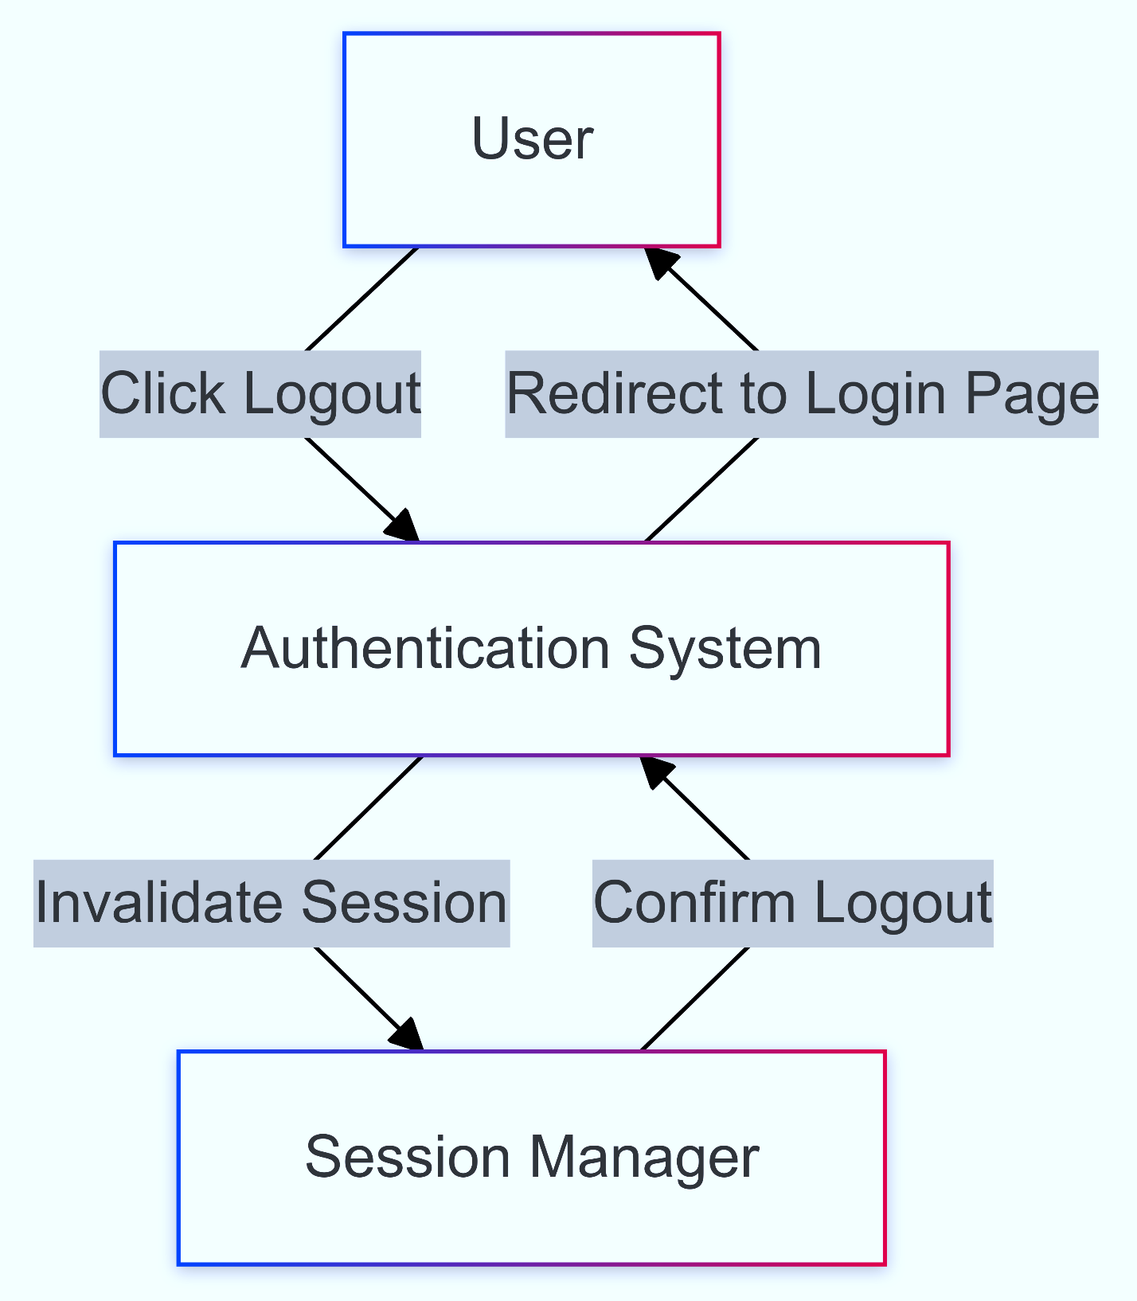

Figure 4. Logout

# Project Details

In this project there are 5 types of users (Admin, Moderator, Accountant, Teacher and Student). Every type of user has its own dashboard. Every user need to login using their unique userID. The work of every dashboard is as follow:

## Admin Dashboard

* **Create user:** new user account will be created using the name, UserID, date of birth, father’s name, mother’s name, personal phone number, guardians phone number, present address, permanent address, user’s picture, birth certificate/NID’s pdf, father’s NID pdf, mother NID pdf and an initial password.
* **Attendance:** There will be a dropdown selection box by which the group will be selected (Example: Staff, class-1, class-2, etc.) then all the user’s information (Roll Number, User ID, Name, Last Day present or absent, today (check box)) of that group will appear into a table of 5 column. At the end there is a submit attendance button to submit today’s checked report. Checked report will be saved as “P” and unchecked will be “A”.
* **Report:** there will be 2 date pickers for setting the range and a apply button by which all the payment between the picked date will be shown along with the student user id, category and amount. At the end there will be a summary of that with the total payment history appeared and total amount.
* **Tuition fees:** there will be a input box to enter the user id, a dropdown selection box to select the bill category, a search button will find the id from the database then if that bill is paid there will be a paid message and if not paid then there will be 3 input box for Amount, Payment Status and Payment Date(automatically pick the current date and can be change), then a submit button. By submitting it the data will be stored in the database.
* **Logout**.

## Moderator Dashboard

* **Attendance:** There will be a dropdown selection box by which the group will be selected (Example: Staff, class-1, class-2, etc.) then all the user’s information (Roll Number, User ID, Name, Last Day present or absent, today (check box)) of that group will appear into a table of 5 column. At the end there is a submit attendance button to submit today’s checked report. Checked report will be saved as “P” and unchecked will be “A”.
* **Create user:** new user account (only teacher and student) will be created using the name, UserID, date of birth, father’s name, mother’s name, personal phone number, guardians phone number, present address, permanent address, user’s picture, birth certificate/NID’s pdf, father’s NID pdf, mother NID pdf and an initial password.
* **View Profile:** there is an input box to enter the user id and an apply button to load the information. Moderator can view all user profile except admin. Profile picture, name, roll number and a dropdown selection box to select the result of 1st term, 2nd term or Annul exam is to show. Then the full result of that term will be visible. Result contain Subject, Full Marks, Written, MCQ, Practical, Total, Highest, Letter Grade, Grade Point, Total of Monthly Exam, 20% of Monthly Exam, GPA without Additional Subject, GPA with Additional Subject, Comment, Total Marks, Procured Marks.
* **My profile:** Profile Picture, Name, User ID, Date of Birth, Father's Name, Mother's Name, Guardian's Contact, Present Address, Permanent Address. Then there will be 3 input boxes for changing Password, they are: Current password, New Password, Re-enter New Password. Then a submit button. By submitting the new password will be replaced with the old password in the database and a message will be shown that “Password change successfully”.
* **Logout.**

## Teacher

* **Attendance:** There will be a dropdown selection box by which the group will be selected (Example: Class-1, class-2, etc.) except staff. Then all the user’s information (Roll Number, User ID, Name, Last Day present or absent, Today (check box)) of that group will appear in a table of 5 column. At the end there is a submit attendance button to submit today’s checked report. Checked report will be saved as “P” and unchecked will be “A”.
* **Classwork:** Here all the assigned subjects will appear and by clicking on them he can post lessons of that subject. There will be a text box and a post button to post.
* **Result:** an input box for entering student user id then search button. By this the user id, name and roll number will appear, after this the teacher needs to select the class and subject from the selection box(the items will appear based on the classes and subjects assigned to that teacher.) then to enter the mark there will be for input box for Full Marks, Written, MCQ, Practical, Total, Highest, Letter Grade, Grade Point, Total of Monthly Exam of that subject. Then a submit button to save the data to the database.
* **My profile:** Profile Picture, Name, User ID, Date of Birth, Father's Name, Mother's Name, Guardian's Contact, Present Address, Permanent Address. Then there will be 3 input boxes for changing Password, they are: Current password, New Password, Re-enter New Password. Then a submit button. By submitting the new password will be replaced with the old password in the database and a message will be shown that “Password change successfully”.
* **Student Profile:** there is an input box to enter the user id and an apply button to load the information. Profile picture, name, roll number and a dropdown selection box to select the result of 1st term, 2nd term or Annul exam is to show. Then the full result of that term will be visible. Result contain Subject, Full Marks, Written, MCQ, Practical, Total, Highest, Letter Grade, Grade Point, Total of Monthly Exam, 20% of Monthly Exam, GPA without Additional Subject, GPA with Additional Subject, Comment, Total Marks, Procured Marks.
* **Logout.**

## Accountant

* **Tuition fees:** there will be a input box to enter the user id, a dropdown selection box to select the bill category, a search button will find the id from the database then if that bill is paid there will be a paid message and if not paid then there will be 3 input box for Amount, Payment Status and Payment Date(automatically pick the current date and can be change), then a submit button. By submitting it the data will be stored in the database.
* **My profile:** Profile Picture, Name, User ID, Date of Birth, Father's Name, Mother's Name, Guardian's Contact, Present Address, Permanent Address. Then there will be 3 input boxes for changing Password, they are: Current password, New Password, Re-enter New Password. Then a submit button. By submitting the new password will be replaced with the old password in the database and a message will be shown that “Password change successfully”.
* **Logout.**

## Student:

* **Classwork:** The assigned class will be connected to the dashboard and assigned subjects to that class will appear here in the table with columns of Subject and Lesson. Before the table there will be a date picker (loaded with current date) so that the students can check the previous day’s lesson.
* **Attendance:** A dropdown selection box to select the month (current month will be preloaded). Then there will be a calendar like table where the present days will be green and absent will be red filled box. The weekly holydays will be ash colored.
* **Tuition fees:** A table with column consists of Category, Amount, Status (Paid/due), Payment Date (If paid) with the payment records.
* **My profile:** Profile Picture, Name, User ID, Date of Birth, Father's Name, Mother's Name, Guardian's Contact, Present Address, Permanent Address. Then there will be 3 input boxes for changing Password, they are: Current password, New Password, Re-enter New Password. Then a submit button. By submitting the new password will be replaced with the old password in the database and a message will be shown that “Password change successfully”.
* **Logout.**

# Conclusion

The development of the School Management Web Application is a significant step toward modernizing and streamlining administrative and academic operations in educational institutions. The application seeks to bridge the gap between instructors, students, and school administration by providing a consolidated, user-friendly platform, hence improving communication, efficiency, and accessibility.

This initiative not only streamlines regular chores like attendance monitoring, marksheet creation, and tuition money administration, but it also gives students access to their academic progress and attendance records, instilling a sense of accountability and involvement. Furthermore, the application's capacity to process leave applications and other administrative requirements digitally demonstrates a dedication to environmentally friendly and paperless operations.

This project aims to provide a scalable and reliable solution that satisfies the changing demands of schools in the digital era through thorough planning, requirement collection, and user-centered design. Finally, the successful implementation of this platform will result in a more structured, transparent, and effective educational environment for all stakeholders.

A digitalized school management system is being developed from the sketch and during this project it feels like doing Web Application and Internet course and the revision of DBMS and System Analysis course with my dream project.